**Assessment Part 1**

The definition of GUI（Graphical User Interface）is to use graphics as work elements and mouse, keyboard collaboration as the main input tool. In the majority of cases, GUI uses a large number of icons to identify commands, meanwhile, by organizing buttons, toolbars, dialogs and other elements to try to improve the intuitive interface and ease of use. In general, GUI looks more beautiful because it uses a lot of graphic elements. However, CLI (Command Line User Interface) naturally refers to the way in which the text is the main working element and the keyboard is the input tool. CLI sends all kinds of instructions directly to the computer by inputting commands and parameters. Therefore, command line generated maps try to improve productivity by organizing input of parameters and commands. Graphical components can also be used in CLI to make the interface more beautiful. But those do not have the actual command functionality that GUI does.

The source of the data used in GUI mapping is reliable. According to the proportion of driving to work in the Great London area compared with the total number of commuters, the corresponding data are obtained. The data used to create the maps, although limited to subjects, is not necessarily accurate and comprehensive, still have very strong reference value. On the other hand, the data source which is to produce the command line generated map is more accurate.

It could be said that the command line is the best way to work with the computer. When making maps with command line interface, the only thing needed to do is selecting the appropriate parameters, typing in, then enter and waiting for the result. This kind of method is so convenient that could be saved as a script for future direct innovation. This approach is characterized by the fact that, while there is no intuitive reflection of the implementation results, they are guaranteed to be consistent with your intentions. In the most cases, when users are making command line generated maps, their intent is always transmitted precisely to the system in the form of command and parameter. As a result, it could be found that the system has done a good and strict job to finish the map. When making maps with GUI, the shortcomings of CLI could be overcome to a certain extent, and the input and output of software can be displayed in a more humanized form, thus making the software easier to use and intuitive. By providing a set of graphical controls, users can interact with computers in a more natural way. On this condition, the GUI-based maps could be more attractive. Nevertheless, no matter how beautiful the interface, it needs to be “command” to the computer to play its role. GUI-based maps cannot be as efficient and accurate as Command line generated maps.

The workflow of the GUI-based software is as following. First, adding network datasets to ArcMap. Then, creating a network analysis map layer. Thirdly, adding network analysis objects. Fourthly, setting the properties of the network analysis layer. Finally, performing the analysis and display the results. As for Command line generated maps, the workflow is more convenient, the result could be generated by typing the command according to the corresponding instruction.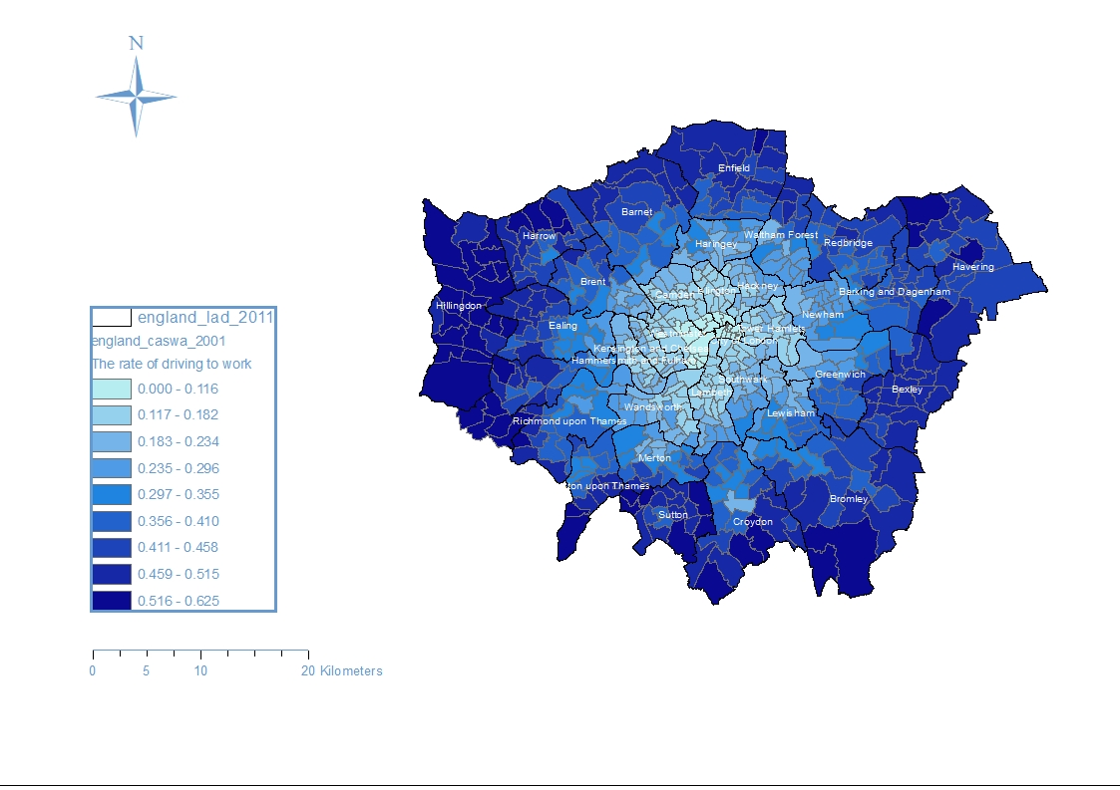

Picture 1. The rate of driving to work (ArcMap)

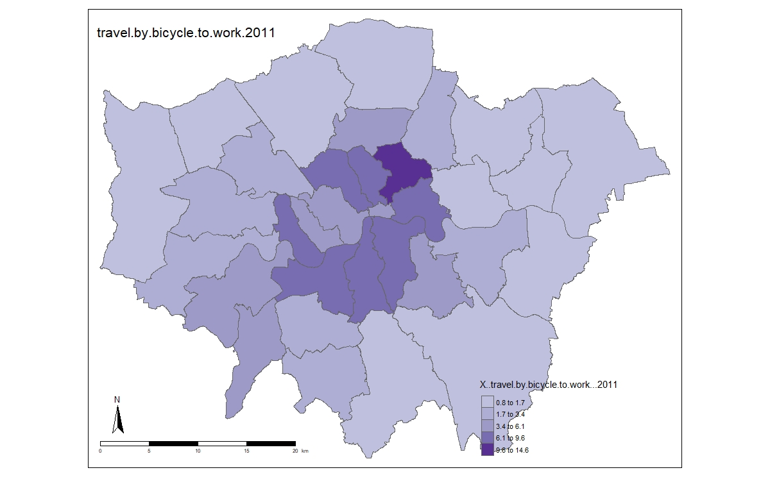

Picture 2. The rate of traveling by bicycle to work (R)